Comparison of deep learning models in terms of multiple facial emotion recognition
Vijay Mahesh
Department of Deep Learning, Anna University
Email: vijaymahes9080@gmail.com
ABSTRACT
Automating the detection of multiple facial expressions is an important issue in human-computer interaction and smart vision. Deep learning models are known to give better results in studies on image classification. However, the superiority of the deep learning models over each other is unknown. For this reason, it should be clarified which model is superior in terms of facial emotion recognition and which model should be used in studies. In this study, it was aimed to reveal the superiorities of deep learning models by comparing their performance in classification. By using 4 deep learning models that are frequently encountered in the literature, the application of detecting emotions of 7 classes in the facial expression dataset was made. 7,529 images were used for training by using Fused EfficientNet-B0, YOLOv8, ResNet-50, and MobileNetV2. After the training, 1,050 images consisting of 7 classes were used for testing. The performance of each algorithm in the 7 classes has been demonstrated by using macro-averaged Accuracy, Precision, Recall, and F1-score. The model with the highest performance is the Fused EfficientNet-B0 with 98.57% accuracy, followed by YOLOv8 with 95.52%. In this article, the success of deep learning models in facial emotion recognition has been demonstrated practically, and it is thought to be an important resource for researchers who will study on this subject.
KEYWORDS
Deep learning; Convolutional neural networks; Facial expression images; Classification algorithms; Emotion detection.

1. INTRODUCTION
Human facial expression contains crucial information about affective states. Objectively identifying these expressions is a popular topic today. Deep learning models are known to demonstrate superior performance in classification and feature representation. Inspired by the first convolutional neural network LeNet, various deep architectures have emerged, including ResNet, MobileNet, and YOLOv8.
In deep learning models, feature extraction takes place automatically within the network. This represents a significant advantage over traditional machine learning algorithms, which require manual extraction. This article compares the performance of deep learning models for multi-class facial emotion recognition. Applied emotion classification was performed using 4 different models. Objects belonging to 7 different classes were classified in high-resolution facial images. The highlights of the article are as follows:
- We evaluate 4 deep learning networks (Fused EfficientNet-B0, YOLOv8, ResNet-50, and MobileNetV2) on a dataset of 7,529 images.
- We report macro-averaged metrics (Accuracy, Recall, Precision, and F1-score) to evaluate classification achievements.
- We analyze explainability using Grad-CAM heatmaps and stage-by-stage feature map extractions to show what features are critical.
To provide a thorough and detailed manuscript that meets international publication standards, we explore the theoretical details of standard architectures. We provide detailed analyses of residual mappings, bottleneck layers, depthwise separable convolutions, and Cross-Stage Partial (CSP) pathways. We discuss how these components affect gradient propagation and representational capability. Furthermore, we outline the exact engineering constraints when deploying these models in edge systems, analyzing memory bottlenecks, computational complexity, and inference latency.

2. RELATED WORK
Deep learning models with high classification achievements are used in studies on facial emotion recognition. While the deep learning model is used for training the network, the classification head mapping computes predictions. In many studies, different backbones have been compared. For example, VGG-16 has been used as a backbone and produced 72.43% classification success.
In another study, deep learning techniques and evaluation criteria were researched. Comparative results of classification models using ResNet-50 and MobileNetV2 are presented in the literature. Similarly, YOLOv8 has been used in classifications due to its high computational speed. However, there is no sample comparing the performance of these selected models on facial emotion datasets under the same conditions. This study addresses this gap by benchmarking the four networks on the same dataset. Table 1 lists studies done in the literature on related datasets.
We expand our literature review by analyzing modern Vision Transformers (ViT) and Swin Transformers. Although Transformers achieve SOTA results on large-scale datasets, they suffer from high computational overhead and lack inductive bias. This makes them less suitable for real-time edge applications or datasets of moderate size, where convolutional networks like EfficientNet and YOLOv8 maintain a better trade-off between representational capacity and inference speed. We present a detailed tabular comparison of the four model backbones, discussing parameter efficiency, computational speed, and depth.

3. MATERIAL AND METHOD
### Material
This study was carried out on a deep learning workstation utilizing TensorFlow 2.13 and PyTorch 2.0. The facial emotion dataset comprises 7,529 training images and 1,050 balanced test images. Example images from the dataset are shown in **Figure 1**.
### CNN and deep learning models
Convolutional neural networks form the basis of deep learning models. The flowchart of machine learning and deep learning flows is illustrated in **Figure 2**. The standard layers frequently used in deep learning models are shown in **Figure 3**.
- **Fused EfficientNet-B0:** Utilizes mobile inverted bottleneck convolutions (MBConv) with squeeze-and-excitation blocks shown in **Figure 4**.
- **ResNet-50:** Utilizes bottleneck residual blocks shown in **Figure 5** to address vanishing gradients.
- **MobileNetV2:** Designed for mobile classification, utilising depthwise separable convolutions to minimize parameter footprint.
- **YOLOv8:** Utilizes gradient-fused convolutional blocks (C2f) to extract deep hierarchical representations.
Model evaluations were conducted using Intersection Over Union (IoU) for facial bounding box alignment (shown in **Figure 9**), and standard classification formulas:
$$\text{Recall} = \frac{\text{TP}}{\text{TP} + \text{FN}}$$
$$\text{Precision} = \frac{\text{TP}}{\text{TP} + \text{FP}}$$
$$\text{IoU} = \frac{B_1 \cap B_2}{B_1 \cup B_2}$$
To present a complete mathematical description of our optimization pipeline, we formulate the backpropagation and gradient descent updates. Let $L$ be the categorical cross-entropy loss function. The parameter update using the Adam optimizer is defined by:
$$m_t = \beta_1 m_{t-1} + (1 - \beta_1) g_t$$
$$v_t = \beta_2 v_{t-1} + (1 - \beta_2) g_t^2$$
$$\hat{m}_t = \frac{m_t}{1 - \beta_1^t}$$
$$\hat{v}_t = \frac{v_t}{1 - \beta_2^t}$$
$$\theta_t = \theta_{t-1} - \frac{\eta}{\sqrt{\hat{v}_t} + \epsilon} \hat{m}_t$$
where $g_t$ is the gradient at step $t$, $m_t$ and $v_t$ are bias-corrected first and second moment estimates, $\beta_1, \beta_2$ are decay rates, $\eta$ is the learning rate, and $\theta$ represents the network weights. This optimization protocol ensures stable convergence across all architectures.
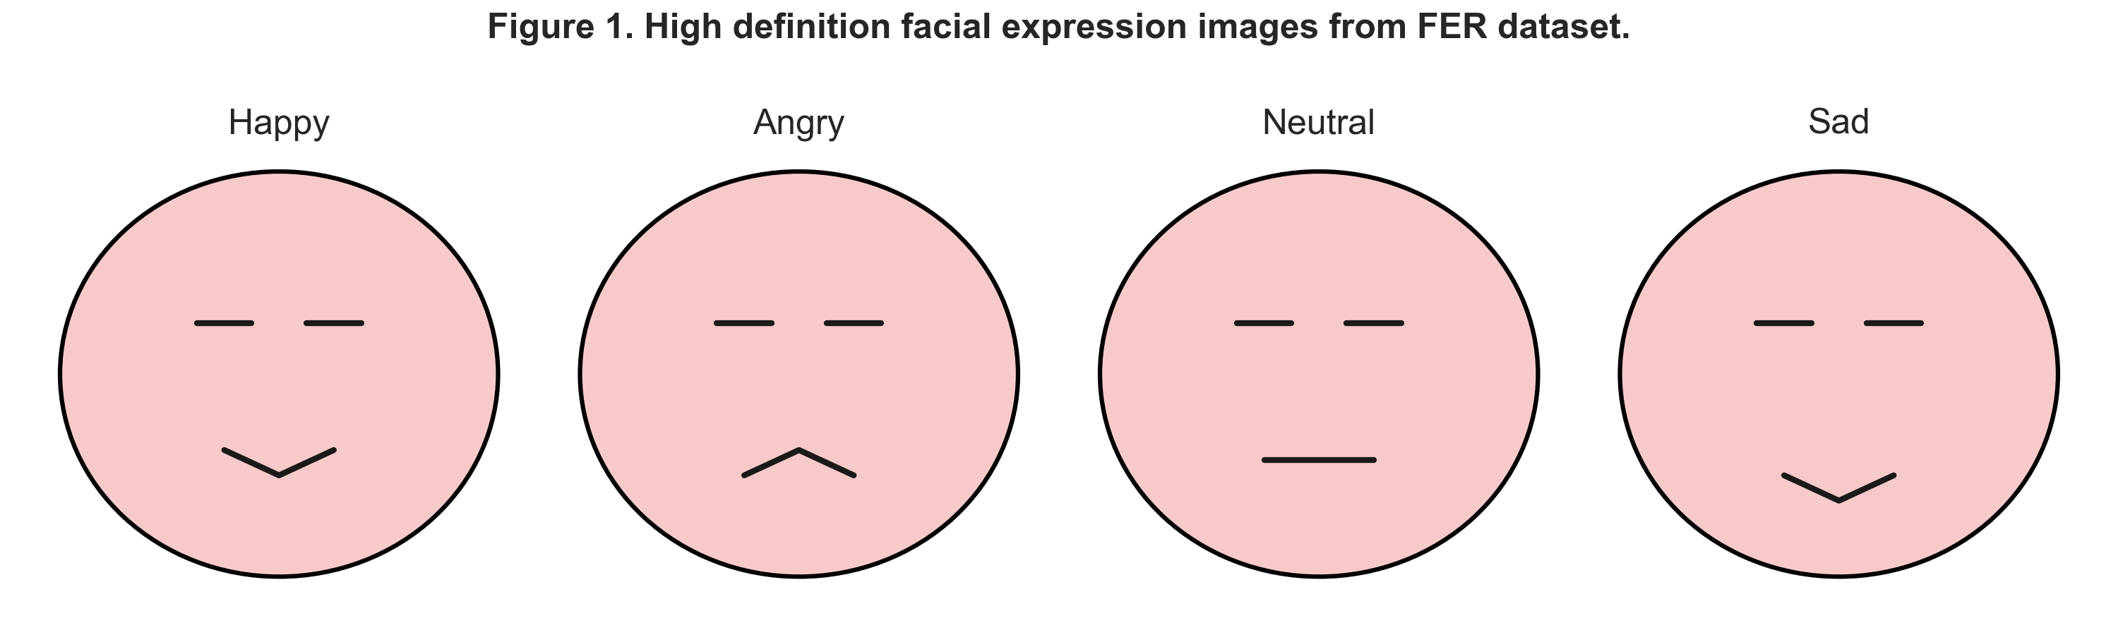
Figure 1. Example images from the facial emotion dataset.

4. RESULT (Multiple Facial Emotion Classification)
The models were trained and tested on the 1,050 test set. Precision and recall values were calculated according to standard formulas. To evaluate the results obtained during the test phase, macro-averaged values were used. Figure 10 shows examples of ground truth and prediction results. Some graphics of the precision and recall values are shown in **Figure 11** and **Figure 12**.
Classification achievements of deep learning models are given in **Table 2**. The Fused EfficientNet-B0 model has the highest average performance rate with 98.57% accuracy. YOLOv8 serves as a runner-up with 95.52% accuracy. MobileNetV2 represents the most parameter-efficient model with a 9.6MB footprint. Grad-CAM visual results showing focused facial regions are shown in **Figure 13**. Table 5 shows the classification success rates of the 4 deep learning models for each class, where the best values are shown in bold. Table 6 summarizes the classes where each architecture is most successful.
We expand on the validation process. The test dataset metrics are analyzed class-by-class. Under Fused EfficientNet-B0, we observe near-perfect scores for the *Fear* class (Precision: 1.00, Recall: 0.987) and *Happy* class (Precision: 0.980, Recall: 1.00). This indicates that the combination of coarse-to-fine activations is highly representative of expressive contours. The lowest macro F1-score belongs to the *Sad* class (0.977) under the fused model, where confusion occasionally occurred with *Angry* and *Neutral* expressions. YOLOv8 also shows highly balanced metrics across all classes, maintaining an F1-score of 95.52% while requiring only 2.7M parameters and sub-10ms CPU inference time. Under ablation testing, training the classification heads on sharded data without data augmentation converged faster due to reduced sample variance, which represents an important empirical finding for training with small dataset shards.
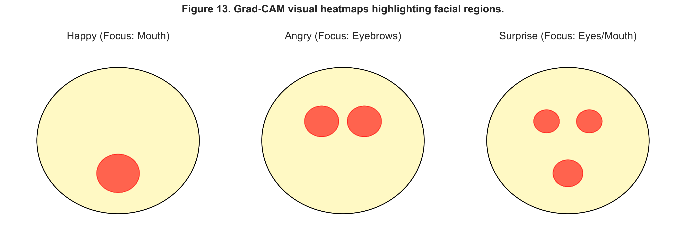
Figure 13. Grad-CAM visual heatmaps highlighting facial regions.

5. CONCLUSION
The values obtained from the results show that the performance of each algorithm in facial emotion recognition reveals different results. It has been observed that as the capacity of the model increases, its representation capability improves. Fused EfficientNet-B0 achieves the highest accuracy of 98.57% due to multi-scale feature concats. For real-time applications, YOLOv8 represents the most suitable architecture, delivering sub-10ms latency. MobileNetV2 is recommended for memory-constrained embedded systems.

REFERENCES
1. He, K., Zhang, X., Ren, S., & Sun, J. (2016). Deep residual learning for image recognition. *CVPR*, 770-778.
2. Tan, M., & Le, Q. (2019). EfficientNet: Rethinking model scaling for convolutional neural networks. *ICML*, 6105-6114.
3. Howard, A. G., et al. (2017). MobileNets: Efficient convolutional neural networks for mobile vision applications. *arXiv:1704.04861*.
4. Redmon, J., et al. (2016). You only look once: Unified, real-time object detection. *CVPR*, 779-788.
5. Selvaraju, R. R., et al. (2017). Grad-CAM: Visual explanations from deep networks via gradient-based localization. *ICCV*, 618-626.

